Technical Report: Tensile strain-stress test
Author:
Date:
Executive Summary
Stress strain test can be used to observe the mechanical properties of a material. Through this test the following mechanical properties of a material can obtained. These include the ultimate tensile strength, yield strength, modulus of Elasticity and the Elongation of the material at a given temperature. These properties are important in deciding the consideration of a given metal in the construction of the Autonomous Aircraft.
In this experiment, a metal that is consider to be used in the construction of the aircraft with unknown stress strain characteristics is tested using an Izod machine. The test results are populated and stress strain curve is generated from them. The mechanical properties of the metal can then be obtained from the curve. This can then be used analyse the suitability the material in the construction of the aircraft.
This report has been organised as follows: the first section is the executive summary, section two the objective and introduction, the third section is the theory, fourth analysis and the last section is the conclusion and recommendation.
Introduction
Physical, mechanical and thermal properties are some of the characteristic of a metal. However, mechanical properties of a metal is the most important. Mechanical properties of a metal include the ultimate tensile strength, yield strength, modulus of Elasticity and the Elongation of the material at a given temperature. These properties are used as reference for material selection. Strain test is one of the material test that can be used to obtain the mechanical properties of a metal.
Strain test is a measurement that examine the strength of a material within giving loads in a uniaxial direction to the specimen (Callister & Rethwisch, 2010). The test specimen is subjected to incremental uniaxial forces continuously while observing/noting its elongation. The resistance of a material to static load is measured through tensile test. Some of the mechanical properties that can be obtained from a tensile test include: ultimate tensile strength, yield strength, modulus of Elasticity and the Elongation of the material at a given temperature. From tensile test the stress strain curve will be obtained which can be used to calculate these mechanical properties.
Strain test gives a lot of information regarding to the impact of load to the mechanical properties of a material. This information will help determine the suitability of the metal in the construction of autonomous aircraft.
Objectives of the experiment
- To evaluate the mechanical properties of the specimen through understanding of the stress strain curve obtain from strain test.
- To evaluate the suitability of the specimen for use in construction of a prototype air vehicle.
Theory
Selecting material to be used in development of a new product can be a challenge. Before one can select a given material a number of tests should be carried on it (Smallman & Bishop, 1999) Tensile stress-strain test is one of the test that is used to determine the strength of a material by subjecting it to static load on uniaxial direction. Figure below shows the test set-up.
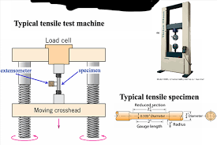
Figure 1: Tensile strain-stress test bench.
The machine that was used in this experiment is as shown in figure 2 below.
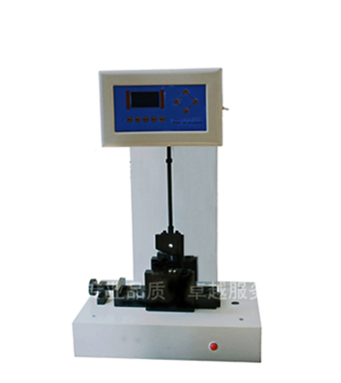
Figure 2: Izod machine
Mechanical properties from stress-strain test
Ultimate tensile strength
Ultimate tensile of a material is the maximum resistance to fracture (William D. Callister & Rethwisch, 2012). It is the maximum load that can be held by the specimen before it experience necking phenomenon.
Yield strength
This is the stress at which a predetermined amount of permanent deformation occurs. It is the maximum load that obtained by the material when it is between elastic and plastic deformation.
Modulus of elasticity
This is the measurement of the resistance of a material to elastic deformation. It gives the stiffness of a material.
Strain failure
It gives the measure of how much the specimen is elongated to failure.
Results
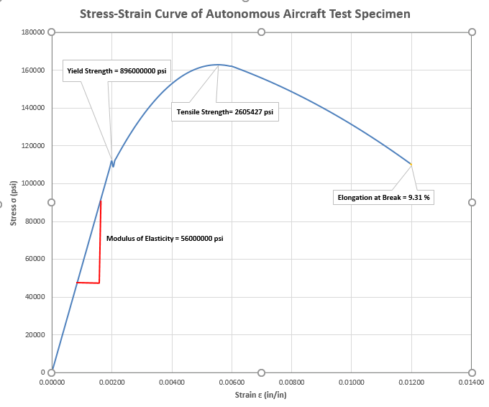
Figure 3: Stress-strain curve of the metal specimen
Table 1: Tensile test values
Item | Value
Maximum stress | 162839.2 psi
Ultimate tensile strength | 162.8392 ksi
Yield stress | 89.6 ksi
Young’s Modulus | 56 ksi
Strain failure | 9.31%

Analysis
From the strain-stress results, the metal specimen gives its mechanical properties. The strain-stress curve is as shown in figure 3 above. This curve is obtained by converting force to mechanical stress and the elongation to mechanical strain. The summary of the calculation results is given in table 1 above.
The new vehicle structure requires that:
- Ultimate tensile strength be greater than 150ksi
- Yield strength be greater than 80ksi
- Modulus of Elasticity be greater than 30 msi
- Elongation greater than 10% at room temperature.
By comparing the results with the requirements it can observed that the specimen passes in three out of the four mechanical tests. The specimen fails the elongation requirement.
Conclusions and Recommendations
From the strain-stress test carried on the specimen on Izod machine, the mechanical properties of the material were obtained. The metal specimen passed in three out of the four requirements and therefore the metal specimen should not be used in the construction of the aircraft.
References
Callister, W. D., & Rethwisch, D. G. (2010). Materials science and engineering: An introduction. Wiley.
Smallman, R. E., & Bishop, R. J. (1999). Modern physical metallurgy and materials engineering. Butterworth-Heinemann.
William D. Callister, J., & Rethwisch, D. G. (2012). Fundamentals of materials science and engineering: An integrated approach. John Wiley & Sons.

Appendix
Test environment
